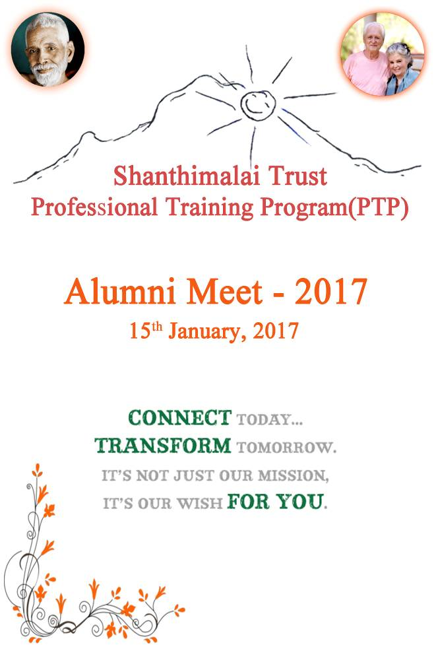

PTP Alumni 2017:

1.

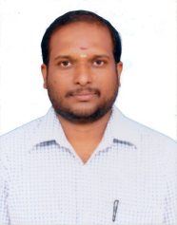Name : **Sathish A**

Address : MGR Nagar, Perumbakkam Road, Ramanshramam Post, Tiruvannamalai.

Village : **KARAI**

Under Sponsorship : 1996-2001, 6 Years Schooling

Under PTP : 2001-2004, 3 Years College

School : Sri Ramana Maharishi Matriculation Higher secondary school.

College : Bachelor of Physics in Govt. Arts & Science College, Master of Physics in Annamalai University, Master of Business Administration in Azhagappa University, Diploma in Industrial Safety.

Job : Working as an Assistant Scientist in Indira Gandhi Centre for Atomic Research , Kalpakkam.

Marital Status : Married.

Wife Name : Tamil Selvi

2.

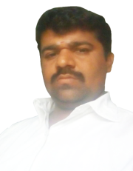 Name : **Govindaraj K**

Address : 696, Mgr Nagar Perumpakkam Road, Ramanashramam Post, Tiruvannamalai.

Village : **KARAI**

Under Sponsorship : 1990-2002, 12 Years Schooling

Under PTP : 2002-2007, 5 Years College

School : Sri Ramana Maharishi Matriculation Higher secondary school.

College : Bachelor of English in Govt. Arts college, Master of English in Muthurangam Arts College, Master of Philosophy(English) in Dravidian University, Bachelor of Education in Pondicherry University, Master of Political Science in Madras University, A Doctor of Philosophy Undergoing in Annamalai University.

Job : Working as an Assistant Professor in Shanmuga Industries Arts & Science College, Tiruvannamalai.

Marital Status : Married.

Wife Name : Mageswari

Child Name : 1. Pradeep (8 Years old)

2. Gokul (6 Years old)

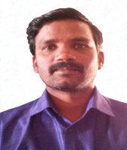

3.

Name : **Sakthivel R**

Address : No.101, Kananthampoondi Village, Pandithapattu Post, Tiruvannamalai.

Village : **KANANTHAMPOONDI**

Under Sponsorship : 1987-1999, 12 Years Schooling

Under PTP : 2005-2006, 1 Year College

School : Sri Ramana Maharishi Matriculation Higher secondary school.

College : Bachelor of Maths in Govt. Arts & Science College, Bachelor of Education, Master of Maths and Master of philosophy in Presidency College.

Job : Working as an BT Assistant in Government High school, Devanur.

Marital Status : Married.

Wife Name : K.P. Shanmuga Priya

Child Name : S.S Dhanuja Jayasri (3yrs old)

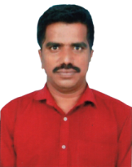

4.

Name : **Vinoba D**

Address : Kananthampoondi Village, Pandithapattu Post, Tiruvannamalai.

Village : **KANANTHAMPOONDI**

Under Sponsorship : 1990-2002, 12 Years Schooling

Under PTP : 2002-2005, 3 Year College

School : Sri Ramana Maharishi Matriculation Higher secondary school.

College : Bachelor of Maths in Madras University, Master of Maths in Annamalai University, Bachelor of Education(maths) in Arunachala College of Education, Master of philosophy in Thiruvalluvar University.

Job : Working as an Assistant Professor in Shanmuga Industries Arts & Science College, Tiruvannamalai.

Marital Status : Unmarried.

5.

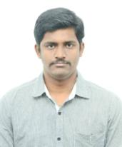Name : **Sathish K**

Address : Kananthampoondi Village, Pandithapattu Post. Tiruvannamalai.

Village : **KANANTHAMPOONDI**

Under Sponsorship : 2000-2002, 2 Years Schooling

Under PTP : 2009-2015, 5 Years College

School : Sri Ramana Maharishi Matriculation Higher secondary school.

College : Bachelor of Medicine, Bachelor of Surgery in Coimbatore Medical College, Coimbatore.

Job : Working as an Doctor in Jawaharlal Institute of Postgraduate Medical Education and Research, Pondicherry.

Marital Status : Unmarried.

6.

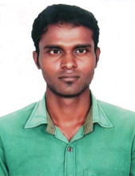Name : **Arun A**

Address : No. 16 Athiyandal Village, Ayyampalayam Post

Village : **ATHIYANDAL**

Under Sponsorship : 1998-2010, 12Years Schooling.

Under PTP : 2010–2014, 4 Years College.

School : Sri Ramana Maharishi Matriculation Higher secondary school.

College : Bachelor of Computer Science Engineering in Arunai College of Engineering, T.V.Malai.

Job : Working as an Technical Support in Cholamandalam Finance Company, Chennai.

Marital Status : Unmarried.

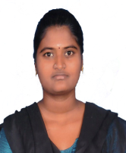

7.

Name : **Jesika M**

Address : No. 457, Annanagar, Kuppanatham, Chengam

Village : **CHENGAM**

Under Sponsorship : 1999-2011, 12Years Schooling.

Under PTP : 2011 – 2015, 4 Years College.

School : Sri Ramana Maharishi Matriculation Higher secondary school.

College : Bachelor of English in Kamban Arts & science college, Bachelor of Education(English) in Chezian College of Education.

Job : Working as an Teacher in Sri Bhagavan higher secondary school, Tiruvannamalai

Marital Status : Unmarried.

8.

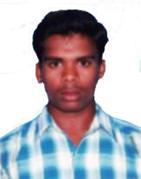Name : **Jayachandran E**

Address : No. 8, Perumbakkam Village, Pandithapattu Post.

Village : **PERUMPAKKAM**

Under Sponsorship : 1999-2011, 12Years Schooling.

Under PTP : 2010 – 2014, 4 Years College.

School : Sri Ramana Maharishi Matriculation Higher secondary school.

College : Bachelor of Mechanical Engineering in Arunai College of Engineering, T.V.Malai

Job : Working as an Assistant Technical in Srushty Global Solutions PVT Ltd, Chennai.

Marital Status : Unmarried.

9.

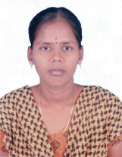Name : **Nithya K.S**

Address : No. 174, Mariyamman Kovil street, Kilchettipattu Village.

Village : **KILCHETTIPATTU**

Under Sponsorship : 1998-2010, 12Years Schooling.

Under PTP : 2010–2016, 6 Years College.

School : Sri Ramana Maharishi Matriculation Higher secondary school.

College : Bachelor of English in Govt. Arts & science college, Bachelor of Education(English) in Chezian College of Education, Master of English in SDNB Vaishnav College, Chennai.

Job : Working as an Teacher in Sri Bhagavan Matriculation higher secondary school, Tiruvannamalai

Marital Status : Unmarried.

10.

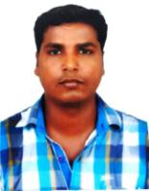Name : **Elumalai K**

Address : No. 26, Renugopal Street, Periyapalaypattu(V & P).

Village : **PERIYAPALYAPATTU**

Under Sponsorship : 1999-2011, 12Years Schooling.

Under PTP : 2011 – 2015, 4 Years College.

School : Sri Ramana Maharishi Matriculation Higher secondary school.

College : Bachelor of Mechanical Engineering in Thiruvalluvar College of Engineering, Vandavasi.

Job : Working as an Senior Analyst in Barclays Shared Services, Chennai.

Marital Status : Unmarried.

11.

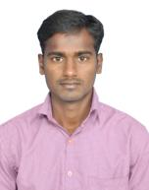Name : Arul E

Address : No. 240, Mummorthi Nagar, Pandithapattu Village & Post.

Village : **PANDITHAPATTU**

Under Sponsorship : 2004-2006, 2Years Schooling.

Under PTP : 2006 – 2008, 2 Years College.

School : Sri Ramana Maharishi Matriculation Higher secondary school.

College : Diploma in Electrical and Electronic Engineering in Vignesh Polytechnic college, Bachelor of Electrical and Electronic Engineering in SKP Engineering College, T.V.Malai.

Job : Entrepreneurship in Recycling

Marital Status : Unmarried.

From Application to Employment

**Out-come**

**Every Year  
June / July**

Shanthimalai Trust  
Professional Training Program (PTP)

Medical Support

Notebooks& Stationery

College & Hostel Fee

Support to start up own venture

Guidance Counselling

Negotiation

with Companies

Industrial Visits

Soft Skills Training

Organizing Interviews

Training on Job Interviews

Training on Employability Skill

Placement Services

PTP Students  
Vocational/Para medicine/Arts & Science/Masters Degree

Two level selection process by Board members

**About our Trust:**

Since 1986, Shanthimalai Trust at Athiyandal village, near Tiruvannamalai, Tamilnadu, has served as a nucleus for the development and upliftment of rural people in Tiruvannamalai District. This area is one of the most backward in all South India. The Trust serves in the areas of health, education and income generation. In line with the motto of our Founder -- **'Help for Self-Help'**-- several of its previous units have become independent.  The main focus of the Trust's activities is now on healthcare, education with sponsorship and post-secondary school (professional training) programs.

**About the Professional Training Program of Shanthimalai**

Through our Professional Training program (PTP), we have helped more than 400 village students pursue their higher education in various fields (engineering, polytechnic, ITI, special education, paramedical, science, etc.).

We also offer them placement services and soft skills training (English, computer & general knowledge) every Sunday. These skills increase the chances our graduates will compete successfully in today’s tough job markets.

1. **Vision and Mission of the PTP**

**Vision**

“Help for Self Help” – Transforming the lives of the poor by providing job-related and entrepreneurial training.

**Mission**

* To create work through entrepreneurship, and to maximize employment opportunities for the young generation
* to help village students pursue their higher education in various fields (engineering, polytechnic, ITI, special education, paramedical, science, etc.),
* to increase the chances of graduates to compete successfully in today’s tough job markets,

by means of

* counselling and training for young people to improve their employability,
* placement services and soft skills training (English, computer & general knowledge),
* industrial visits and exposure,
* entrepreneurial guidance through access to databases, Information Centers and Techndical Information Sections attached to the District Industries Centers,
* healthcare and support for critical needs,
* a network of sustainable and scalable social enterprises throughout the region.

**Values**

Trust, equality, respect, commitment and compassion, regardless of caste and income.

1. **Selection and Admission to the PTP**

2.1 As per the PTP objectives, mission and vision, student selection follows the principle of **academic performance** as the best available predictor for future performance in professional education. In addition, the personal **ability of self-expression** of the applicant is important. Quality counts, not quantity. Students must be deserving (intelligent, and knowledgeable). The level of English (written and spoken) shall be evaluated by a qualified teacher before admission to the PTP, to ensure requirements are met.

However, the PTP as such is not a support program only on the basis of material needs of applicants or their families. The Trust offers various other opportunities for this kind of needs.

2.2 The **number of students** to be taken in depends on the budget available from the Trust, and is set by the Trust Management each year. The number of students in the PTP at any one time shall not exceed **400** students in total. The annual intake shall not exceed a maximum of **100** students, if possible, less.

As a priority,

* 40 per cent of the places will be provided for Vocational and Paramedical courses,
* 40 per cent of the places will be provided for Undergraduate studies,
* 20 per cent of the places will be provided for other categories.

2.3 Applications, which fulfill one or more of the following criteria **shall not be admitted**:

* Low academic performance
* Wealthy family background
* Courses which do not offer subsequent employment opportunities (no demand in job market)
* Requesting PTP support for more than two courses (except sponsor parent support students)
* Families requesting support for more than one child (one family – one child)
* Families requesting PTP support to be transferred from one child to another child
* Families getting continuous support from Shanthimalai
* Existing PTP students with poor attendance of PTP classes

2.4 The **amount** of stipend granted as stipulated in the former guidelines are obsolet since focus and purpose of selection have changed over time to placement success after vocational training and other education.

2.5 The Pre-selection Committee members shall select the beneficiaries by personal interview, final selection starts in the **first week of August**, run by the final selection committee. Students will be called for interview based on their course category.

The **final selection committee** will include Dr Peter (Chair), Mr Sridar Ganesh, Mr Venkatesan, Ms Viji, and one more person (e.g. Dr Andreas, Dr Ruediger) to be nominated by the Chair closer to the time.

1. **Measuring program effectiveness**

To ensure academic and personal progress of PTP students, their performance will be checked annually during the program, specifically in terms of academic performance, English (written and spoken), PTP-class attendance and contribution. Such key performance indicators shall be defined by the Program Lead and reviewed each year whether or not they are useful and appropriate. Statistics of correlation of PTP performance with later job-placement-success shall be provided.

Stipends can be cancelled when students do not meet the minimum levels required at the discretion of the PTP Lead, but not before discussion with the EC.

4. This policy **replaces and superseeds** all other former policies or guidelines issued. Existing and new forms and tools for use in administration processes (e.g. selection, assessment, performance) shall be part of and in line with this policy.

PTP Activities:

**“The main aim of this activity is to create more local employment”**

**1. Industrial Visits:** Industrial visits are important to any student pursuing careers in fields such as engineering, business management, biotechnology, pharmacy, architecture and more. No institute providing these courses has got enough infrastructure to show-case all the real working equipment, operational methodology and everything else- that students will come across once they graduate and enter into their chosen professional field. Industrial tours are an effort to bridge this gap and provide practical exposure.

**2. Sunday Classes (Soft Skills Training):**

- English language

- Embedded System (for engineering students)

- Computer class

- General knowledge

- Training on renewable energy(solar)

- Coaching for job applications and interviews

- Counselling

**3. Placement Services:** In another proactive step, PTP conducts job fairs to help PTP graduates find employment opportunities. Through this initiative, PTP has been able to facilitate job placement for **80-to-90** PTP graduates to date.

**4. Entrepreneurs Development Program:** This program helps young entrepreneurs identify potential markets and prepare project profiles required to apply for funding assistance from banks/financial institutions. Other supports include:

* Technical counselling and resources to learn about the policies and programs of the state / central governments, through seminars and information sessions.
* Entrepreneurial guidance through database, Information Centers and Technical Information Sections attached to the District Industries Centers.

|  |  |  |
| --- | --- | --- |
| **SHANTHIMALAI TRUST** | | |
| **Professional Training Program (PTP)** | | |
| **Current Student List (2016-17)** | | |
| **S.No.** | **Details** | **No. of  Student** |
|  | Total No. of Students | 414 |
|  | Breakdown by course |  |
| 1 | Industrial Training (ITI) | 18 |
| 2 | Polytechnic-Diploma Eng. | 58 |
| 3 | Bachelor of Nursing (Dip, DNA, DPN) | 42 |
| 4 | Special Teacher for MR/CP | 4 |
| 5 | Bachelor of Engineering | |
|  | * Mechanical | 33 |
|  | * Electrical and communication | 25 |
|  | * Electrical and Electronic | 20 |
|  | * Computer Science | 17 |
|  | * Civil | 16 |
| 6 | Bachelor of Arts & Science | |
|  | * Computer Science | 40 |
|  | * English | 32 |
|  | * Mathematics | 26 |
|  | * Physics | 20 |
|  | * Chemistry | 14 |
|  | * Commerce | 19 |
|  | * Agriculture | 5 |
| 7 | Master of Arts, Science, Commerce | 15 |
| 8 | Teacher training | 2 |
| 9 | Medicine | 4 |
| 10 | SIDHA | 3 |
| 11 | Doctorate (Ph.D) | 1 |
|  | **Total** | **414** |

**Status of 2015-16 Graduates**

**Auroville an experimental township**

Pondicherry.

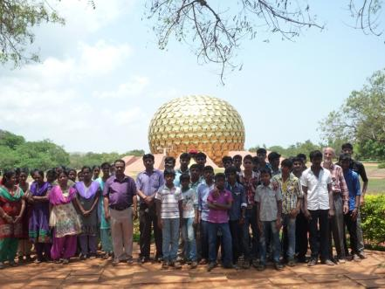

**Auroville Globe**

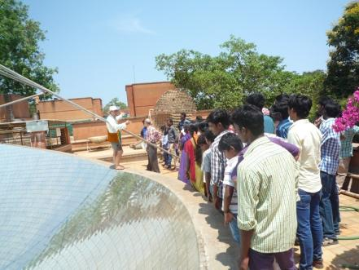

**Solar Kitchen**

**TI-Bicycle Manufacturing Limited**

Chennai

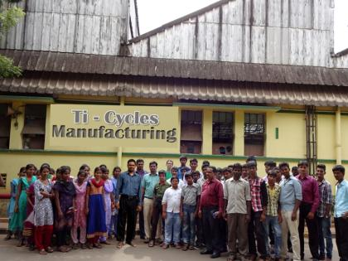

**TI Cycles Front View**

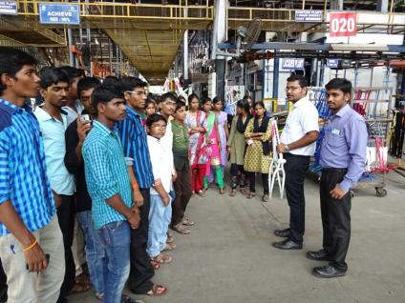

**TI Cycles- Production Area**

**Indian Institute of Crop Processing Technology**

Thanjavur.

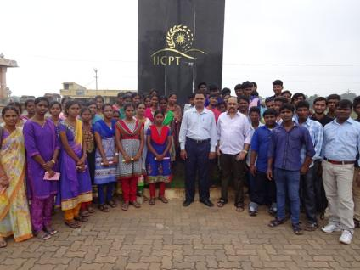

**IICPT Entrance**

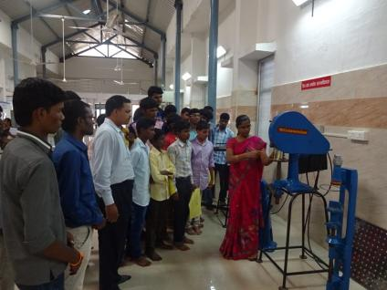

**Product demonstration**

**Microcontroller Workshop in TIDEL PARK**

Chennai.

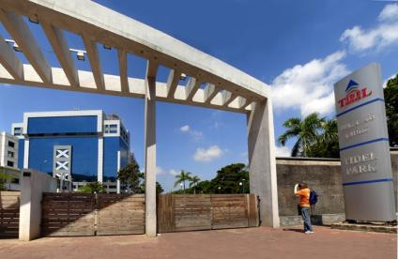

**TIDEL PARK front view**

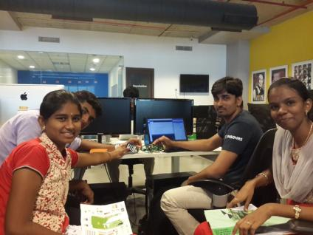

**Project demonstration**

**Embedded Systems**

**Sunday Classes**

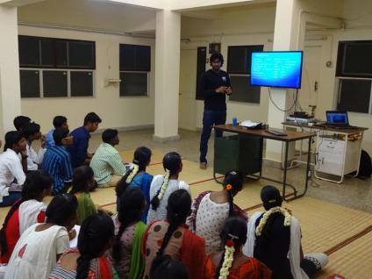

**Micro-controller theory class**

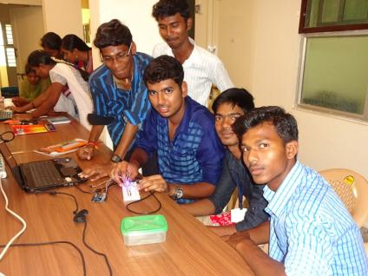

**Micro-controller practical session**

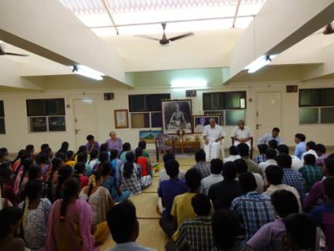

**Counselling**

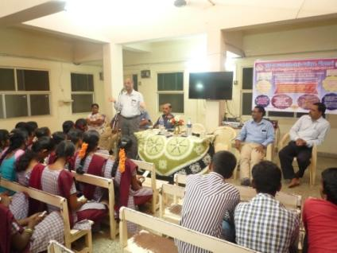

**Counselling for college students**

**Counselling for school students**

PTP Team:

1. Dr. Peter Hellerich

2. Mr. Sridhar Ganesh

3. Venkatesan G

4. Ashok E

5. Prakash V

6. Arun A

7. Rajiv Gandhi R

8. Parasakthi C

9. Kalaiyarasi V

10. Nithya K.S

11. Karthi P

**Volunteer & Trainer:**

1.Mr. Thirumalai Muthu

|  |  |  |
| --- | --- | --- |
| **S.no** | **List of Educational Partners** |  |
| 1 | Arunai Engineering College, Tiruvannamalai |  |
| 2 | S.K.P Institute of Technology - Tiruvannamalai |  |
| 3 | Sri Sakthi Polytechnic College - Chengam | Vocational Training |
| 4 | Vignesh Polytechnic College, Tiruvannamalai |
| 5 | Thirumala Polytechnic College, Tiruvannamalai |
| 6 | Rajalakshmi Polytechnic College - Somasipadi |
| 7 | TVS Polytechnic, Chennai |
| 8 | Gedee Technical Training Institute - Coimbatore |
| 9 | Kamban ITI - Tiruvannamalai |
| 10 | Sri Srinivasa ITI - Thandarampattu |
| 11 | Arunai ITI, Tiruvannamalai |
| 12 | Vishan Paramedical, Tiruvannamalai |  |
| 13 | Sri Narayani College of Nursing, Vellore |  |
| 14 | Annamalaiyar Paramedical, Tiruvannamalai |  |
| 15 | Vingesh Nursing College Tiruvannamalai |  |
| 16 | KMC College of Nursing - Trichi |  |
| 17 | Kamalakshi Pandurangan College of Pharmacy, Tiruvannamalai |  |
| 18 | Srinivasa Paramedical College - Tiruvannamalai |  |
| 19 | Vingesh Nursing College Tiruvannamalai |  |
| 20 | Al-Ameen College of Nursing - Somasipadi |  |
| 21 | Paul Institute of Sp.Tr. Training, Thandarampattu |  |
| 22 | Amirtha Institue of Hotel Management Chennai |  |
| 23 | Annamal Insitute of Hotel Management, Tiruvannamalai |  |
| 24 | Shanmuga Arts & Sci. College, Tiruvannamalai |  |
| 25 | Indian Arts & Science College, Tiruvannamalai |  |
| 26 | Sun Arts & Sci. College, Keeranur |  |
| 27 | Kamban art & science College, Tiruvannamalai |  |
| 28 | Ramakrishna Mission Vivekananda College, Chennai |  |
| 29 | Arunai Vidhya Arts & Science College, Tiruvannamalai |  |
| 30 | Loyola College, Vettavalam |  |

|  |  |
| --- | --- |
| **S.No** | **List of Partnering Companies** |
| **1** | **Aagna Global Solution Private Limited, Chennai** |
| **2** | **Cholamandalam Investment and Finance Company Ltd** |
| **3** | **ETCO Digital Private Limited, Chennai** |
| **4** | **ICICI Academy for Skills, Coimbatore** |
| **5** | **Primo Automation, Chennai** |
| **6** | **Royal Enfield, Chennai** |
| **7** | **SGBS Unnati Skill Centre, Chennai** |
| **8** | **TAFE Power Source Company, Chennai** |
| **9** | **Task Pressings Limited, Chennai** |
| **10** | **Transenergy Limited, Chennai** |
| **11** | **Wichitra Auto Limited, Chennai** |
| **12** | **Dhanalakshmi Srinivasan Chitfunds Pvt. Ltd, T.V.Malai** |
| **13** | **Renault Nissan Automotive India Pvt. Ltd, Chennai** |
| **14** | **Murugappa Groups, Chennai** |
| **15** | **Equitas Holdings Limited, Chennai** |

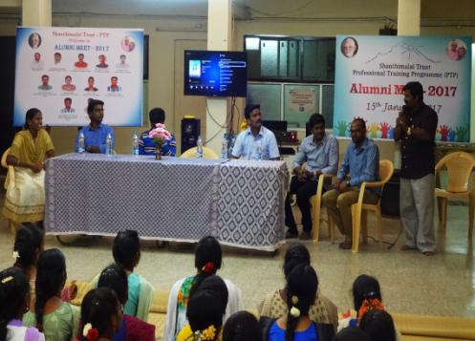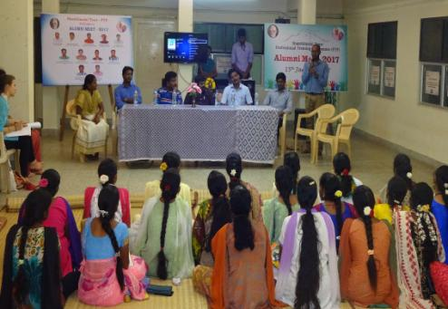

**Mr. Govindharaj (Alumni) sharing his experience**

**Mr. Arun (Alumni) sharing his experience**

**Photos of Alumni Meet 2017**

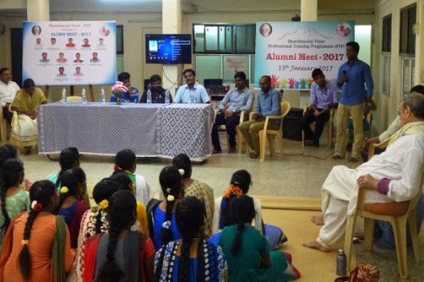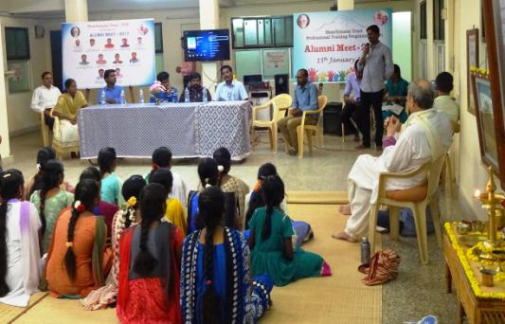

**Mr. Elumalai (Alumni) sharing his experience**

**Mr. Sathish (Alumni) sharing his experience**

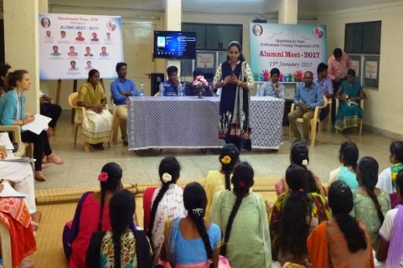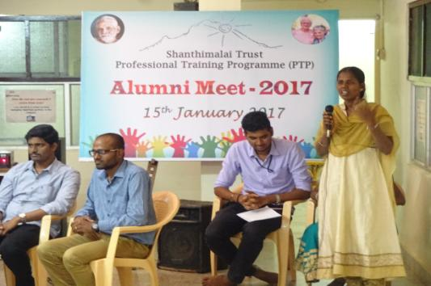

**Ms. Rajeshwari delivering motivational talk**

**Ms. Nithya (Alumni) sharing her experience**

Thanking you

  
[www.arunapartnership.org](http://www.arunapartnership.org)  
[www.stiftung-aruna.ch](http://www.stiftung-aruna.ch)  
[www.freundeskreisindien.de](http://www.freundeskreisindien.de)

www.facebook.com/smtptp